**Unit 2 | Assignment - The VBA of Wall Street**

**Easy**

* Create a script that will loop through each year of stock data and grab the total amount of volume each stock had over the year.
  + You will also need to display the ticker symbol to coincide with the total volume.

**2014**

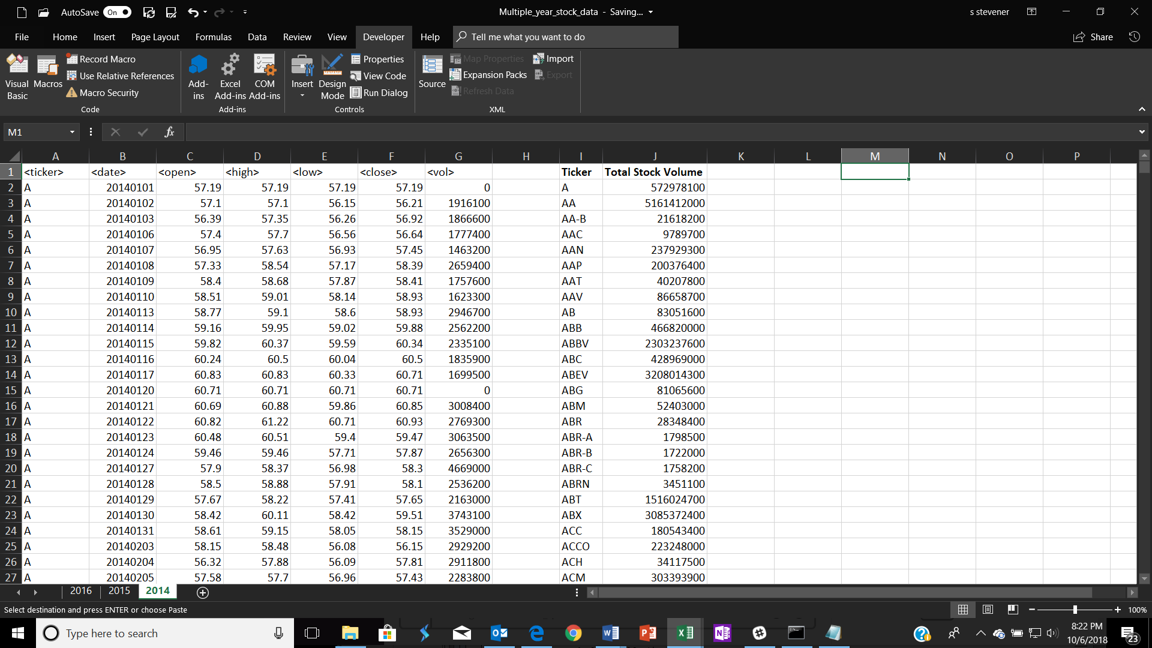

**2015**

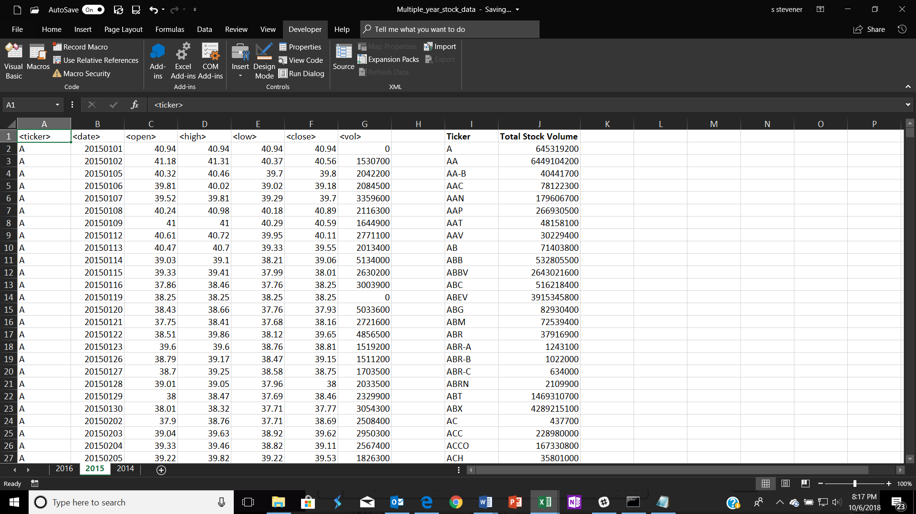

**2016**

